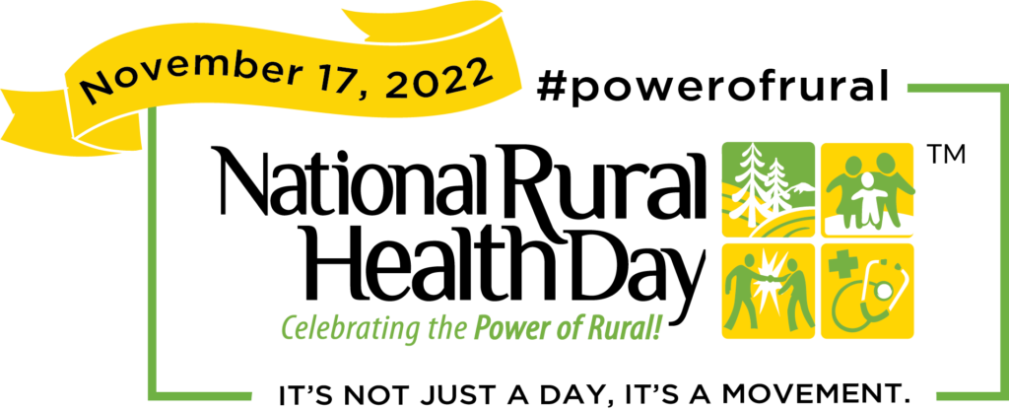

**2022 Rural Health Day**

Join us in celebrating the “Power of Rural” in recognition of Missouri Rural Health Day on Nov. 17 at the Governor’s Office Building from 9 a.m. – 3 p.m. Interact with others and engage on rural health topics impacting Missourians. Registration for the event is free. For more information, contact the Office of Rural Health at 573-751-6219 or [ORHPCinfo@health.mo.gov](mailto:ORHPCinfo@health.mo.gov).